Ideation Phase Define the Problem Statements

|  |  |
| --- | --- |
| Date | 19 September 2022 |
| Team ID | PNT2022TMID26105 |
| Project Name | Project – IoT based Real time river water  quality Monitoring and Control System |
| Maximum Marks | 2 Marks |

Customer Problem Statement:

The contamination of water has become a common problem globally. The conventional methods of monitoring involves manual collecting water sample from different locations and tested in the laboratory using the rigororous skills. Such approaches are time consuming and are no longer to be considered to be efficient. Moreover, the current methodologies include analyzing various kinds of physical and chemical parameters. The old methods of quality detection and communication is time consuming, low precision and costly . Therefore**,** there is a need for continuous monitoring of water quality system in real time. By focusing on the above issues, low cost monitoring system to monitor water in real time using IoT is proposed.In this system quality parameters are measured using different sensors such as pH,turbidity, temperature and communicating data onto a platform microcontroller system and GPRS are used.

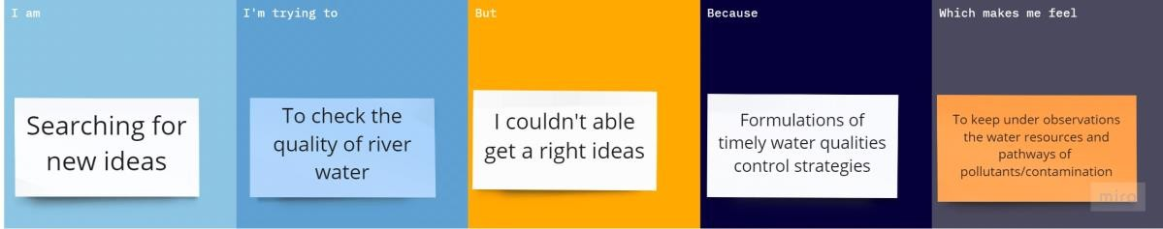

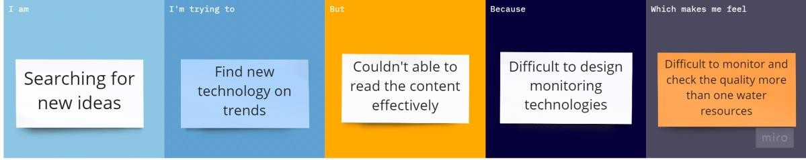

|  |  |  |  |  |  |
| --- | --- | --- | --- | --- | --- |
| **Problem Statement**  **(PS)** | **I am (Customer)** | **I’m trying to** | **But** | **Because** | **Which makes me feel** |
| PS-1 | Searching for new ideas | To check the quality of river water | I couldn’t able  get a right ideas | Formulations of timely water qualities control strategies | To keep under observations the water resources and pathways of pollutants / contamination |
| PS-2 | Searching for new ideas | Find new technology on  trends | I couldn’t able to read the content effectively | Difficult to design monitoring technologies | Difficult to monitor  and check the quality more than one water  resources |

Reference: <https://miro.com/templates/customer-problem-statement/>